Full Build

Introduction
Two key issues must be determined before a Full Build can be successfully completed:
- Build Stores
- Distribution List

Terms
The following table list terms and definitions pertaining to Full Build:
Term | Definition
PLU | Price Look-up
DUP | Duplicate
XXXX | Store #
RBM | Robot
MD/PC | Markdown/Price change
EC/DBM | Department at JFF. Means Electronic Commerce Database Management Department
Builds | The Stores that will be build and distributed to all other stores.
Distribution List | Document listing all stores and the builds these stores will receive.
JFFPLUS | When the job JFF850 runs, the data is compiled from the Item Master file and is copied to the Library JFFPLUS, sorted by Store number.
09998 | Lab’s store #
Fullbld | The Full Build Batch file used to create the 13 Build Files from the ALT and PLU files.
UPC | Universal Price Code
DBM | Data Base Manager

Table of Contents
The following table lists the sections in this topic:
Topic 1: Full Build 1
Section 1: Hold PLU, PLU850 and ProcessPC Jobs 3
Section 2: Disable ConnectRemote 5
Section 3: Input and Release MD/PC Entries 7
Section 4: Process Pending MD/PC Entries 8
Section 5: Print Pending MD/PC Schedule 11
Section 6: Format MD/PC Entries for PLU 13
Section 7: Verify Prices 15
Section 8: Run JFF850 18
Section 9: Clear Library JFFPLUS 20
Section 10: Information to ITS 22
Section 11: Create PLU by Item Range, as needed 23
Section 12: Define Job Schedules, as needed 28
Section 13: Manually Run Job from Job List 32
Section 14: Start Job Schedule 34
Section 15: Run JFF850 36
Section 16: Display, Rename and Create the Library JFFPLUS 38
Section 17: FTP Files to Network (per Build Store) 43
Section 18: Run FullBld to Create 13 Build Files (per Build Store) and Review 46
Section 19: Send Build to Lab for Testing 49
Section 20: ConnectRemote Send (per Build Store) 53
Section 21: Verify Necessary Files Are At Store 58
Section 22: Verify Files are Updated at the Store 61
Section 23: Release PLU, PLU850 and ProcessPC 66
Section 24: Manual Send (per Build Store) 68
Section 25: Alternate Manual Send 70
Section 26: Overview 72
Section 27: Time Comparison 74
Section 28: Checklist 75
Section 29: Full Build Flowchart 76

Hold PLU, PLU850 and ProcessPC Jobs

Purpose
Hold PLU keeps the PLU and ProcessPC jobs from starting during the Full Build process.

Note: This cannot be started until the Buyers have completed entering pricing for the day.

Requested by
EC/DBM

Completed by
ITS Operations

Platform and Application
AS/400

Procedures
Follow the steps to Hold PLU, PLU850 and ProcessPC jobs:
Step | Action
 | Logon the AS/400.
 | Press F12 to open a command line.
Type:
RBM
Press enter to choose the Robot command.
RBM.gif

Type:
1
Press enter to choose Job Schedule List.
Press F9 for Job Name.

The Search Options Screen opens.
Type:
1
Press enter for Job Name.
In the “Job Name” field, type:
PLU
Press enter.

The PLU job will move to the top of the list.
In the “Option” field for PLU, type:
H
Press enter.
The Job will be marked Hold.
In the “Job Name” field, type:
PLU
Press enter.

The PLU job will move to the top of the list.
In the “Option” field for PLU850, type:
H
Press enter.
The Job will be marked Hold.
In the “Job Name” field, type:
Pro
Press enter.

The ProcessPC job will move to the top of the list.
In the “Option” field for ProcessPC, type:
H
Press enter.
The Job will be marked Hold.
Press F3 to exit.

Hold PLU, PLU850 and ProcessPC Jobs.

Disable ConnectRemote

Purpose
During the Full Build process, the stores only receive selected files from the Build Stores. To keep the stores from receiving information not applicable for them, two jobs in ConnectRemote are disabled.
- PLU Download to Store
- PLU Download from AS/400

Completed by
ITS Operations

Platform and Application
RemoteWare

Procedures
Follow the steps to Disable ConnectRemote:
Step | Action
On the RemoteWare Terminal, open RemoteWare software by choosing:

Start → Programs → RemoteWare Server → RemoteWare Menu

Or choose icon named RemoteWare Menu from the Desktop.

The RemoteWare main window opens.
RemoteWare_Main_Menu.gif

Double click the Session Editor Icon.
The Session Editor window opens.
Using the scroll bar, scroll through the Sessions list to find and choose:
PLU Download to Store
Right click on PLU Download to Store, and choose Disable from the pulldown menu.
The system will return to the Session Editor.
Using the scroll bar, scroll through the Sessions list to find and choose:
PLU Download from AS/400
Right click on PLU Download from AS/400, and choose Disable from the pull down menu.

Disable Connect Remote.

Input and Release MD/PC Entries

Purpose
The EC/DBM Department is responsible for retrieving the pricing list from the Buyers and manually keying the correct price into IP. You must input and release all prices before you can Process and Format. Each time you enter overlapping/conflicting prices, you must re-run the Process and Format functions.

Completed by
EC/DBM

Platform and Application
AS/400

Input PC/MD Entries.

Format MD/PC Entries for PLU

Purpose
This procedure is used to create register specific price files for the PLU download when a non-Island Pacific polling program is to be used. PLU changes caused by permanent price changes, temporary markdowns, deletions, changes to UPC’s and/or the addition of new items in Merchandising must be formatted for PLU download.

Note: This job cannot be started until the DBM has completed entering pricing for the day.

Completed by
EC/DBM

Est. Duration
30 minutes – 12 hours

Platform and Application
AS/400

Procedures
Follow the steps to Format MD/PC Entries for PLU:
Step | Action
On the selection line, type:
27
Press F2 to choose Polling Definition and Control Menu.
Menu027.gif

Type:
13
Press enter to choose Format MD/PC Entries for PLU.

The Format MD Instructions for PLU screen appears.
Press enter to accept the defaults on this screen.
On the field named, “Enter the name of the output queue for this job,” type:
Pricing
Press enter.
Sec02.05.gif

The system will process for a moment, then return to Menu 27 Polling Definitions and Control.

Format MD/PC Entries for PLU.

Print Pending MD/PC Schedule

Purpose
The Schedule should not have any items pending. If there are any items pending, you must run the option to Process Pending MD/PC Entries.

Completed by
EC/DBM

Est. Duration
5 –30 minutes

Platform and Application
AS/400

Procedures
Follow the steps to Print Pending MD/PC Schedule:
Step | Action
On the selection line, type:
9
Press F2 to choose System Management Menu.
Menu009.gif

Type:
2
Press enter to choose Print Pending MD/PC Schedule. The system will display a messaging stating the Schedule is being prepared.
Sec03.05

The system will process, and return to Menu 9.
Press F12 to open a command line.
To Work With Spooled Files, type:
Wrksplf
Press F4.
The next screen allows you to select your choices. In the field named “User,” type:
*all
Press tab.
Press tab until you reach the “User Data” field, type:
PRT016f
Press enter.
A screen listing all spooled files will appear. Press F10 three times to view the reports by date and time.
Tab to the report with the most current date and time stamp.
To display the report, in the “Options” field type:
5
Press enter to access Display.
The schedule should be empty. If it is not empty, you will need to Process Pending MD/PC Entries.

Print Pending MD/PC Schedule.

Process Pending MD/PC Entries

Purpose
To update the Item Master Header file with new pricing information. This process may need to be executed more than once, depending on the overlapping of prices.

For example:
- Prices are entered at 50% off into the system for Division 20
  - Run Process Pending option
  - Run Print Pending option
  - Run Format option
- Additional T-shirt prices are entered for a specific class, 2101, all vendors.
  - Run Process Pending option
  - Run Print Pending option
  - Run Format option
- T-shirt prices for one vendor are priced at $12.99.
  - Run Process Pending option
  - Run Print Pending option
  - Run Format option

Note: Coordinate plans with Corporate Operations before beginning this process. It will lock store OPS out of receiving POS.

Completed by
EC/DBM

Est. Duration
30 minutes – 12 hours

Platform and Application
AS/400

Procedures
Follow the steps to Process Pending MD/PC Entries:
Step | Action
Send Break Message
Approximately one hour before running Process Pending MD/PC, send a break message to all users alerting them in 60 minutes Batch Receiving will be unavailable until further notice.

To send a break message, choose F4 to Send Message from a selection line.
In the “Message text” field, type:
in 60 minutes Batch Receiving will be unavailable until further notice.
Press tab.
To send the message to all workstations, in the “To user profile” field, type:
*allws
Press enter.

Note: Send break messages at the following intervals:
1 hour before running Process Pending MD/PC
30 minutes before running Process Pending MD/PC
1 minute before running Process Pending MD/PC
Break msg.gif
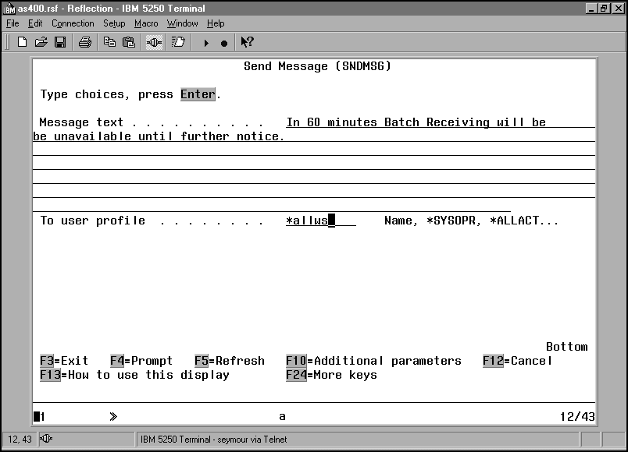
The system will process, then return to a selection line.
Process Pending MD/PC Entries
On the selection line, type:
9
Press F2 to choose the System Management Menu.
Menu009.gif

On the selection line, type:
3
Press enter to choose Process Pending MD/PC Entries.
In the “From” field, type:
01/01/91
Press tab.
In the “To” field, type:
“Effective date”
Press enter. The Job Queue Submission Request window opens.

Note: The Full Build date is the date the prices will go into effect.
Md_pc process.gif

In the “Enter the name of the output queue for this job” field, type:
PRICING
Press F6 to add to the Job List. .
??? – Job Queue - YES
The system will process, then return to Menu 9, System Management.

Process Pending MD/PC Entries.

Verify Prices

Purpose
To insure the prices are correct throughout the Full Build process, the EC/DBM manager will periodically verify the prices assigned to Item Numbers by reviewing the PRT207b report. The PRT207b report lists all prices for all stores.

Sample prices should also be provided to ITS Operations from testing at the Lab before sending Full Build to the stores.

Performed by:
EC/DBM

Platform and Application
AS/400

Procedures
Follow the steps to Verify Prices:
Step | Action
 | Press F12 to open a command line.
To Work With Spooled Files, type:
Wrksplf
Press F4.
The next screen allows you to select your choices. In the field named “User,” type:
*all
Press tab.
Press tab until you reach the “User Data” field, type:
ip207b
Press enter.
Wrksplf.gif

A screen listing all spooled files will appear. Press F10 three times to view the reports by date and time.
Tab to the report with the most current date and time stamp.
To display the report, in the “Options” field type:
5
Press enter to access Display.
Prt207b.gif

To find an item number, in the “Find” field located at the top of the screen. Type:
“first six digits of Item Number”
Press F16.

The cursor will move to the item number.
Repeat finding the item numbers and price for all sample data.
Press F3 to exit to a command line.
Sample prices should also be provided to ITS Operations from testing at the Lab before sending Full Build to the stores.

Verify Prices.

Run JFF850

Purpose
The job JFF850 accesses the data in the Item Master file and builds the PLU and the ALT files for every store and copies it to the Library JFFPLUS. The files are sorted by the store number.

Completed by
EC/DBM

Est. Duration
30 minutes - 12 hours

Platform and Application
AS/400

Procedures
Follow the steps to Run JFF 850:
Step | Action
On the Selection line, type
661
Press F2 to move to Scott’s Menu.
Menu661.gif

Type
36
To choose Submit JFF855.

The Manual Submission of JFF850 screen opens.
A warning message will appear. Type:
Y
Press enter.
Sec05.05

The system will process and return to Menu 661, Scott’s Menu.
Press F12 to open a command line.
To Work with Active Jobs, type:
Wrkactjob
Press enter.

Note: This function is only useful if you can view active jobs while they are running The screen will only show you that the job, JFF850, is running and not what information is being uploaded.
Press Page Down on the keyboard and look for JFF850. Notice if there is any error messages (MSGW) in the status column.

Verify Job JFF850 completed in Subsystem QBATCH
If there are error messages, inform the ITS Operations Department.

Run JFF 850.

Clear Library JFFPLUS

Purpose
All pricing information for all stores is contained in the Library JFFPLUS. If the library is not cleared, additional data will append to the library when ITS runs the job JFF850 again.

Completed by
EC/DBM

Est. Duration
30 minutes

Platform and Application
AS/400

Procedures
Follow the steps to Clear Library JFFPLUS:
Step | Action
On the Selection line, type
216
Press F2 to move to Misc. Menu.
Menu216.gif

Type:
11
Press enter to choose CLRLIB JFFPLUS.
The system will process, then return to Menu 216.

Clear Library JFFPLUS.

Information to ITS

Purpose
Before ITS can proceed with the Full Build process, ITS will need to determine the following:
- Determine Selected Build stores
- Determine Distribution list
- Determine Jobs that need to be created
- Determine Schedules that need to be created
For Example: The Full Build process may need to be processed in groups. See the example below.
- Create Job and Job Schedules, as needed
- Run Schedules
  - Group 1:
    - Run DUPSKU Job Schedule
    - Run FXXXMMDDYY Job Schedule. This builds the data for Full Build Store #XXX.
    - Run JFF850 – Populates Library JFFPLUS with data for Full Build Store #XXX.
    - Rename Library JFFPLUS to FXXXMMDDYY
    - Create Library JFFPLUS
  - Group 2
    - Run FXXXMMDDYY Job Schedule. This builds the data for Full Build Store # XXX.
Note: There is no need to run the DUPSKU Schedule again.
    - Run JFF850 – Populates Library JFFPLUS with data for Full Build Store #XXX.
    - Rename Library JFFPLUS to FXXXMMDDYY
    - Create Library JFFPLUS
  - Group 3
    - Run FBMMDDYY Schedule. This builds the data for all Full Build Stores.
    - Run JFF850 – Populates Library JFFPLUS with data for all Full Build Stores.
    - Rename Library JFFPLUS to FBMMDDYY (or other appropriate name).
    - Create Library JFFPLUS
- FTP Build Store data to Network
  - FTP data for Store #XXX (from Group 1) from Library FXXXMMDDYY to Network
  - FTP data for Store #XXX (from Group 2) from Library FXXXMMDDYY to Network
  - FTP data for all remaining Full Build Stores (from Group 3) from Library FBMMDDYY to Network
Note: Click the below icon to view a sample Distribution List.
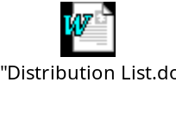

Determine Build Stores.

Create PLU by Item Range, as needed

Purpose
The Full Build Jobs are created in this screen, as needed. The following three jobs are ALWAYS run every Full Build:

- Create PLU for Dup SKUS
- Create PLU for UPC#1
- Create PLU for UPC#2

Note: These Jobs are saved in a Schedule named DUPSKU. It is not necessary to run these jobs individually, run the Schedule instead.

Note: It is only necessary to run the Schedule DUPSKU once. It is not necessary to run it before every Schedule is run.

Any additional Jobs that are needed are created in the Create PLU by Item Range screen. Each Full Build, any additional jobs are created in this screen. After the Job is created it is added to the Mange Job List (10,8). There may be multiple jobs for each Full Build store. All jobs can be added into one schedule, or each job may be saved in it’s own schedule. This is determined by the VP of Business Operations or the ITS Operations Team Lead.

Completed by
VP of Business Operations or ITS Operations Team Lead

Est. Duration
1 hour, 30 minutes

Platform and Application
AS/400

Procedures
Follow the steps to Create PLU by Item Range:
Step | Action
On the selection line, type:
27
Press F2 to choose the Polling Definition and Control Menu.
Menu027.gif

On the selection line, type:
14
Press enter to choose Create PLU by Item Range.
The next screen will request the Item number range. In the “From Item Number” field, type:
    
Press tab.
In the “To Item Number” field, type:
9999 99999 9999 999 9999
Press F8.

The store selection window will open
Create PLU.gif

Type:
5
Press enter for Store.
All store.gif

Type:
“Beginning Build Store XXXX”
Press tab.
Type:
“Ending Build Store XXXX”
Press enter.

Note: To enter additional store ranges, press enter and the system will prompt you for an additional range.
Select Store.gif

For example, enter the below range:
00001→00004
This selects stores 1, 2, 3 & 4.

For example, enter the below range:
00001→00001
This selects store 1 only.
After entering all Build Stores, press F8 to Continue.
Press enter to accept defaults on the next screen.
On the Job Queue screen, in the “Do you want this report or procedure submitted to the job queue,” type:
Y
Press enter.
In the “Enter the name of the output queue for this job,” type:
Pricing
Press tab.
In the “Description of Job” field, type:
Create Full Build for XXX XXX XXX
Press F6 to Add to Job List.

Note: The X’s denote the Build store number(s).
OQ_Create PLU.gif
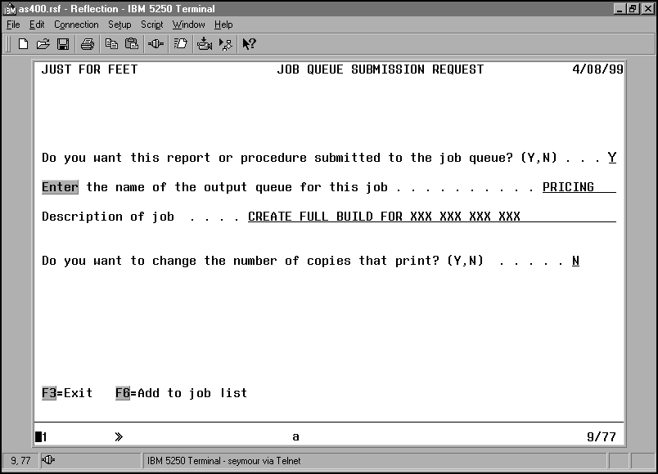
On the next screen, you will receive a message “Information is being added to job list…” Press enter to continue.
System will process and return to Menu 27.

Create PLU by Item Range.

Define Job Schedules, as needed

Purpose
During the Full Build Process, if any Job Schedules are needed, they are created here. In the example in Section 10: , a separate Schedule was created for Full Build Stores XXX, XXX and all remaining stores. A Schedule allows you to prioritize and monitor all job assigned to the Job Schedule.
The Job Schedule naming convention is as follows.
- 1st Job – FXXXMMDDYY
- 2nd Job – FXXXMMDDYY
- 3rd Job – FXXXMMDDYY
- 4th Job – FSSDMMDDYY – This build is for the Specialty Stores.
- 5th Job – FBMMDDYY – All remaining stores.

Completed by
VP of Business Operations or ITS Operations Team Lead

Platform and Application
AS/400

Procedures
Follow the steps to Define Job Schedules:
Step | Action
On the selection line, type:
10
Press F2 to choose the System Definition Menu.
Menu010.gif

On the selection line, type:
7
Press enter to choose Define Job Schedule.
The Define Job Schedule screen will prompt you to enter a name for the Schedule you are creating. Type:
FXXXMMDDYY
Press enter.

Note: The X’s denotes the Full Build Store number or any other identifying factors.
The next screen lists all jobs in the Mange Job List. Scroll to find the job created in Create PLU by Item Range. In the “Option” filed, type:
1
To Include the Job.

Note: Choose all jobs that are included in this Schedule.
Define Job Schedule.gif

After choosing all jobs that need to be included, press enter.

Note: The sequence you choose the jobs, is the sequence the jobs will run in. You will have an opportunity to change the running sequence later.
In the Description field, type:
Full Build for XXX XXX MMDDYY
 | Press F9 to Expand the screen.
 | Field Name | Type | Press
 | Output Queue | Pricing | Tab
 | Wait for all previous jobs to complete? | *YES | Tab
 | Wait for this job to complete? | *YES | Tab
 | If job cannot be started | *Prompt | Tab
 | If conflicts exist | *Prompt | Enter
Define schedule.gif

You will receive the above screen for each Job in the Job Schedule. Complete each screen as above.
After completing all screens, the system will process then return to Menu 10.

Define Job Schedules.

Manually Run Job from Job List

Purpose
If jobs are run from a Job Schedule, it is not necessary to run the jobs from Manage Job List. All jobs can be run manually from the Manage Job List or automatically from a defined Schedule. The advantage of running jobs in a Job Schedule is the jobs are monitored for errors, the schedule prioritizes the jobs, and as each job finishes, the next job is automatically kicked off.

Note: ITS Management prefers all Jobs are run from a Job Schedule, rather than manually from the Manage Job List.

Completed by
ITS Operations

Est. Duration
15 minutes

Platform and Application
AS/400

Procedures
Follow the steps to Manually Run Job from Job List:
Step | Action
On the selection line, type:
10
Press F2 to choose the System Definition Menu.
Menu010.gif

On the selection line, type:
8
Press enter to choose Manage Job List.

The system will process for a moment, and then the Manage Job List screen will open.
Scroll until you find the appropriate job:

Note: All appropriate jobs are determined by the ITS Operations Team Lead.
In the selection field for the appropriate job, type:
B
Press enter.
Sec08.05

The system will process and return to Menu 10.
Monitor Jobs
To Work with Active Jobs, type:
Wrkactjob
Press enter.

Note: This function is only useful if you can view active jobs while they are running The screen will only show you that the job, FBXXMMDDYY, is running and not what information is being uploaded.
Press Page Down on the keyboard and look for Subsystem IPTS. Notice if there is any error messages (MSGW) in the status column.
Report any error messages to the ITS Operations Team Lead.

Manually Run Job from Job List.

Start Job Schedule

Purpose
Start Job Schedule executes the Job Schedule created by the Vice President of Business Operations or the ITS Operations Team Lead. There may be more than one Job Schedule that needs to run. For each Scheduled Job, you will need to execute the following before starting the next Schedule.

- Run JFF850
- Rename the Library JFFPLUS to a unique name.
- Create Library JFFPLUS

Note: It is very important that all of the above is complete, before you start the next Schedule.

Completed by
ITS Operations

Platform and Application
AS/400

Procedures
Follow the steps to Start Job Schedule:
Step | Action
On the selection line, type:
10
Press F2 to choose the System Definition Menu.
Menu010.gif

On the selection line, type:
9
Press enter to choose Start Job Schedule.
Type:
“Job Schedule name”
Press enter.

Note: The schedule is created by the Vice President of Business Operations or the ITS Operations Team Lead.
A warning message will appear. Type:
Y
Press enter.
The system will process, then return to Menu 10.
Monitor Jobs
Press F12 to open a command line
To Work with Active Jobs, type:
Wrkactjob
Press enter.

Note: This function is only useful if you can view active jobs while they are running The screen will only show you that the Job Schedule is running.
Press Page Down on the keyboard and look for Subsystem IPTS. Notice if there are any error messages (MSGW) in the status column.
Report any error messages to the ITS Operations Team Lead.

Start Job Schedule.

Run JFF850

Purpose
The job JFF850 accesses the data in the Item Master file and builds the PLU and the ALT files for every store and copies it to the Library JFFPLUS. The files are sorted by the store number.

Completed by
ITS Operations

Est. Duration
30 minutes - 7 hours, 30 minutes
Depending on the number of stores in Build.

Platform and Application
AS/400

Procedures
Follow the steps to Run JFF 850:
Step | Action
On the Selection line, type
661
Press F2 to move to Scott’s Menu.
Menu661.gif
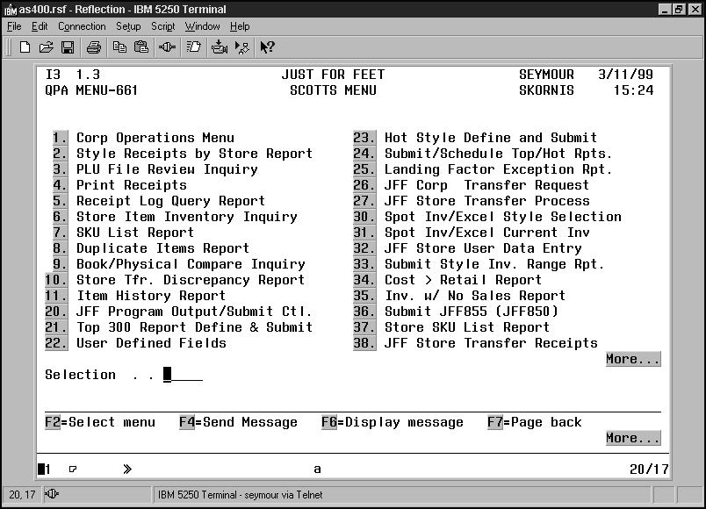
Type
36
To choose Submit JFF855.

The Manual Submission of JFF850 screen opens.
Sec14.05

A warning message will appear. Type:
Y
Press enter.
The system will process and return to Menu 661, Scott’s Menu.
Monitor Job
Press F12 to open a command line.
To Work with Active Jobs, type:
Wrkactjob
Press enter.

Note: This function is only useful if you can view active jobs while they are running The screen will only show you that the job, JFF850, is running.
Press Page Down on the keyboard and look for JFF850. Notice if there is any error messages (MSGW) in the status column.

Verify Job JFF850 completed in Subsystem QBATCH
Report any errors to IP Support.

Run JFF 850.

Display, Rename and Create the Library JFFPLUS

Purpose
The Build stores pricing information is contained in the Library JFFPLUS. The library must be copied to a new location, then deleted, so the ALT and PLU file will not be sent to the store as a change file.

- Display the library JFFPLUS to:
- Verify the ALT and PLU files for all stores were copied to the library.
- Note the size of ALT and PLU files for each Build store.
- The size of the ALT and PLU files for the Build stores should be larger than the other stores.
- Rename the Library JFFPLUS to FXXXMMDDYY. The Build Stores contained in the Library FXXXMMDDYY are FTPed to the network, then sent to the stores. If there are multiple Full Build Jobs, you must rename Library JFFPLUS each time JFF850 is run. The naming convention is as follows.
- 1st Job – FXXXMMDDYY
- 2nd Job – FXXXMMDDYY
- 3rd Job – FXXXMMDDYY
- 4th Job – FSSDMMDDYY – This build is for the Specialty Stores.
- 5th Job – FBMMDDYY – All remaining stores.
Note: The Library name can only be a maximum of 10 character. The X’s denote the Build store number. Not all jobs are run every Full Build process. Only the needed jobs are run.
- Create Library JFFPLUS

Completed by
ITS Operations

Est. Duration
Display Library - 5 minutes
Rename Library - 2 minutes
Create Library – 1 minutes

Platform and Application
AS/400

Procedures
Follow the steps to Display, Rename and Create the Library JFFPLUS:
Step | Action
 | Press F12 to open a command line.
To Work with the Library on a command line, type:
Wrklib JFFPLUS
Press enter.
Display Library JFFPLUS
Tab to the option field for JFFPLUS. Type:
5
Press enter to Display the library.
Wrklib JFFPLUS 5.gif

Note the size of ALTXXXX and PLUXXXX for the Build stores on the Full Build Checklist. The Build store’s size will be larger than the rest of stores.
Press F3 to return to the Work with Libraries screen.
Press F3 to exit to a command line
Rename Library JFFPLUS to FBMMDDYY
On the command line, type:
Wrkobj JFFPLUS
Press enter
Wrkobj jffplus.gif

The Work with Objects screen will appear. In the “Options” filed, type:
7
Press enter for Rename.

Note: If you receive an Object Lock error, contact the ITS Operations Team Lead.
7 Rename.gif

On the Rename Object screen, in the “New Object” field, type:
“FXXXMMDDYY
Press enter.
Fxxxmmddyy.gif

The system will process, then return to the Work with Objects screen.
Press F3 to exit to a command line.
Create Library JFFPLUS
To Create a Library on a command line, type:
Crtlib JFFPLUS
Press F4 for Prompt.
In the “Text Description” field, type:
PLU Build Library
Press enter.
CRTLIB JFFPLUS.GIF

The system will process then return to a command line.

Display, Rename and Create the Library JFFPLUS.

FTP Files to Network (per Build Store)

Purpose
The FTP process copies the ALT and PLU Build files from the Library Ful* for each Job Schedule to F:\POSPOLL\PLUFILES on the network. The Library FXXXMMDDYY is stored at F:\POSPOLL\PLUFILES. In order to access the Library, the Operator will need to log on the AS/400 from a DOS prompt. When the PLU and ALT file are combined, they are saved to F:\\POS\XXXX on the network.

Completed by
ITS Operations

Est. Duration
30 minutes

Platform and Application
DOS

Procedures
Follow the steps to FTP Files to Network:
Step | Action
Choose:

Start → Programs → MS-DOS Prompt

A DOS window will open.
Type:
F:
Press enter.
Type:
Cd \
Press enter.
Type:
Cd OPS
Press enter.
 | Note: When you connect to the server, you can either type the server’s IP address, or you can type the server’s name. The server named Seymour is assigned the IP address 26.100.1.3.
Type: Or, type:
FTP 26.100.1.3 FTP Seymour
Press enter. Press enter.

Note: When connection is successful, you will receive the following message: “Connected to 26.100.1.3”.
System will prompt you for your AS/400 login. Type:
“AS/400 login”
Press enter.
System will prompt you for your AS/400 password. Type:
“AS/400 PASSWORD”
Press enter.

If login is successful, you will receive a “User ID logged on” message.
FTP log on.gif

Type the library name. At the FTP prompt type:
Cd “Copied Library Name”
Press enter.

For example: Type, CD FXXXMMDDYY or type, CD FBMMDDYY
Type:
ASCII
Press enter.
Type:
Prompt
Press enter.
Type:
LCD F:\POSPOLL\PLUFILES
Press enter.

Note: The file path where the copied Library is saved is F:\POSPOLL\PLUFILES.
Type:
GET ALTXXXX
Press enter.

Note: Repeat the Get command for each Build store. The Alt file is saved on the network at F:\POSPOLL\PLUFILES.

Note: As the files are copied, note the file size for each Build Store.
Type:
GET PLUXXXX
Press enter.

Note: Repeat the Get command for each Build store. The Alt file is saved on the network at F:\POSPOLL\PLUFILES.

Note: As the files are copied, note the file size for each Build Store.
Type:
Quit
Press enter to log off the AS/400.
Type:
Exit
Press enter to return exit DOS and return to Windows.

FTP Files to Network.

Run FullBld to Create 13 Build Files (per Build Store) and Review

Purpose
The Full Build batch file (Fullbld.bat) creates the 13 Build files for each Build store from the ALT and PLU files. The FullBld batch file takes the ALT & PLU files saved at F:\\POS\XXXX and compiles them into the 13 Build Files. All 13 Build files must be copied to the store via ConnectRemote. There will be 13 Build Files for EACH of the Build Stores. After the Fullbld batch file completes, the operator will need to review the files,

In Windows Explorer review the 13 Build Files saved at F:\\POS\XXXX for the date, time and size of each file. If the PLU.RPT file exists in the directory, delete the file. The 13 Build files are listed below.
13 Build Files
PLU.DAT
PLU.IX1
PLU.IX2
PLU.IX3
PLU.IX4
MOVEMENT.DAT
MOVEMENT.IX1
SUGGEST.IX1
SUGGEST.DAT
STYLE.DAT
STYLE.IX1
SP.IX1
DCS.IX1
During send, the above 13 Build Files are sent to the store and saved at the store at I:\POS\PLUNEW. When the store runs EOD, these files are moved from that location to I:\POS. In the POS directory, the files are available for the register to ring the correct prices.

Completed by
ITS Operations

Est. Duration
1 hour - 4 hours per store

Note: The duration depends on the size and PC used.

Platform and Application
DOS

Procedures
Follow the steps to Run Full Build to Create Build Files (per Build Store) and Review:
Step | Action
Choose:

Start → Programs → MS-DOS Prompt

A DOS window will open.
Note: Some computers in IP Support are equipped with switch boxes. The correct OPS drive is labeled on each computer. The correct drive will either be C:\ or D:\.

Change to the correct OPS drive. Type: Or, type:
C: D:
Press enter. Press enter.
To keep from receiving break messages during the Full Build process, type:
Send /a=n
Press enter.
Type:
Cd POS
Press enter.
Type:
Fullbld XXXX
Press enter.

Note: Repeat the Fullbld batch file for each Build store.
 | The Fullbld batch file creates the 13 Build files and saves the files at F:\\POS\XXXX.
Type:
Exit
Press enter to Exit DOS and return to Windows.
Review File Size
Choose:

Start → Programs → Windows Explorer

The Windows Explorer screen opens.
Move to the following directory:

F:\\POS\XXXX
 | Review date, time and size of the 13 Build Files for each Build Store. Ensure the file sizes match the file size of the ALT and PLU file.
 | If the PLU.RPT file exists, delete it.
Zip Build Files
In Windows Explorer, move to the following directory:

F:\\POS\XXXX
Choose:

File → Add to Zip
In the “Add to Archive” field, type:
Brms“YYmmdd”

For example: If backup date is 7/8/99, the file name would be BRMS990708.

Note: Use the default file path.
Zip 2.gif
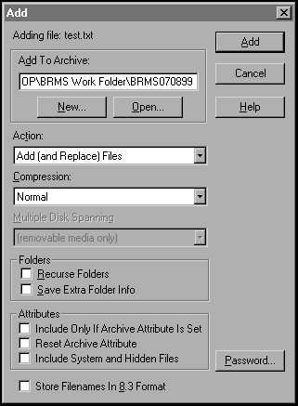
Choose Add.

The WinZip main menu will open.
Zip 3.gif
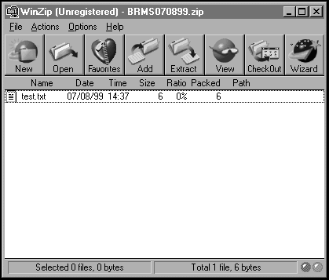
Close the WinZip window.
Create Self Extracting file for Archive
Open the BRMS Work Folder 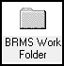 icon.
Press F5 to refresh the screen.
Highlight the BRMSMMDDYY.ZIP file, then right click and choose:
Create Self Extractor (.EXE)
Choose OK.
Choose the “32-bit Windows 95 and NT” radio button.
Choose the “No Spanning” radio button.
BRMS 1
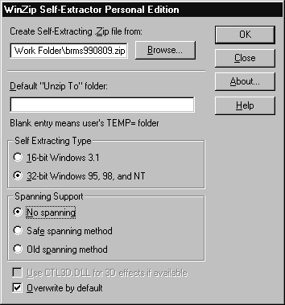
Choose the OK button.
Choose Yes.
Zip 6.gif
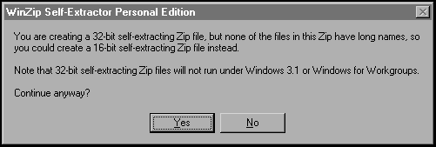
Choose Yes.
Zip 7.gif
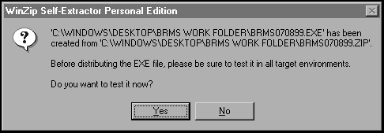
Choose UNZIP, then follow directions on the screen.
Zip 8.gif
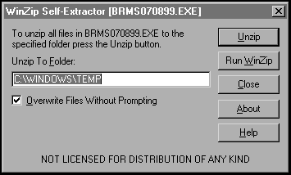
Close the WinZip Self Extractor window.
Close the WinZip Self Extractor Personal Edition window.

Run Full Build to Create Build Files (per Build Store) and Review.

Send Build to Lab for Testing

Purpose
Before the Build is sent to the stores, it is sent to the Lab for testing. This insures all prices are correct.
The steps for sending a test to the Lab are as follows:
- Exit POS on Lab register.
- Send 1st Build to Lab
- Test Pricing (Obtain sample data from EC/DBM Manager)
- Repeat for ALL Build stores.

Test Pricing
If the EC/DBM Manager does not provide the Operator with sample prices, the Operator can obtain sample prices by comparing the prices in the QSYSPRT file to the prices in the PRT207B file. Then the prices are compared to the cash registers in the lab by ringing up the sample item numbers.

Completed by
ITS Operations

Platform and Application
Lab Register

Procedures
Follow the steps to Send Build to Lab for Testing:
Step | Action
Exit POS in Lab Register
 | On Lab register, exit POS
Register must have following message:
“Press S to start.”
Send Build to Lab
Choose:

Start → Programs → MS-DOS Prompt

A DOS window will open.
At the DOS prompt, type:
F:
Press enter.
Type:
Cd \
To change directories to the root directory.
Type:
Cd OPS
Press enter.
Type:
POSMAP 09998
Press enter.
This connect to the store

Note: The Lab’s Store number is 09998.
Type:
F:\
Press enter.
Type:
Cd \
To change directories to the root directory.
Type:
Cd 
Press enter.
Type:
Cd POS
Press enter.
Type:
Cd XXXX
Press enter.

Note: Type the Build Store number from the distribution list. The Lab, store # 09998, will receive the 13 Build Files from the directory you type above.
Type:
Copy *.* I:\POS
Press enter.

Note: This command copies the Build Store files to the store on the distribution list. In this case, the receiving store is the Lab.

Note: You can only copy this entire directory it is contains only the 13 Build files, if the directory contains other data you will need to copy the 13 Build Files separately.

Note: The files are copied to the I:\POS directory instead of the I:\POS\PLUNEW because the register is off.
Test Pricing
 | In Island Pacific, press F12 to obtain a command line.
Type:
Wrkoutq pricing
Press enter.
 | Press F18 to move to the bottom.
 | Find the QSYSPRT file by looking at the time and date stamp. The correct file will have several thousand pages.
In the “Options” field, type:
5
Press enter to Display the file.
 | Page through the file and randomly print approximately five screens from the top, middle and bottom of the file.
 | On each of the print screens, highlight one or two items to use for your test data.
 | Press F3 to exit to return to the Work with Output Queue screen. .
 | Press Page Up until you find the PRT207B file by looking at the time and date stamp. The correct file will have several thousand pages.
In the “Options” field, type:
5
Press enter to Display the file.
 | Tab to the “Find” field.
Type:
Highlighted “Item number” from print screens
Press Shift+F4.

Note: The Item Number is from the screen printed from file QSYSPRT.
 | Verify price and descriptions are the same in both reports.
Tab to the “Control” field, type:
T
Press enter to move to the top of the file.
In the “Control” field, press Field Exit.

The cursor will move to the “Find” field.
 | Repeat process for each highlighted item number.
 | If any prices are incorrect, notify the EC/DBM Manger.
 | Ring test Item #’s on the lab cash registers and verify price is ringing correctly.
 | If prices ring incorrectly, notify the EC/DBM Manger.
 | Repeat this entire process for ALL Build stores.

Send Build to Lab for Testing.

ConnectRemote Send (per Build Store)

Purpose
ConnectRemote runs sessions to connect to the store and copy the Build Files from the network to the store’s directory I:\POS\PLUNEW. When the store runs EOD, the 13 Build Files are moved from I:\POS\PLUNEW to I:\POS. Currently, there are 29 available Full Build sessions.

Completed by
ITS Operations

Est. Duration
1 hour, 15 minutes - 1 hour, 30 minutes per store

Platform and Application
ConnectRemote

Procedures
Follow the steps to ConnectRemote Send (per Build Store):
Step | Action
On the RemoteWare Terminal, open RemoteWare software by choosing:

Start → Programs → RemoteWare Server → RemoteWare Menu

Or choose icon named RemoteWare Menu from the Desktop.

The RemoteWare main window opens.
RemoteWare_Main_Menu.gif

Double click the Client Profile Icon.
The Client Profile window opens.
To insure the proper Build Files are sent to the stores on the distribution list, you must verify the groups associated with the Sessions are correct. Using the scroll bar, scroll through the list to find:

All4JFF – This group contains all stores that will receive Store #4’s build.
All81JFF - This group contains all stores that will receive Store #81’s build.
AllSpec - This group contains all stores that will receive the Specialty Store build.
All110JFF - This group contains all stores that will receive Store #110’s build.
All112JFF - This group contains all stores that will receive Store #112’s build.

Note: Currently, the IP Support Manager determines which sessions to run during the Full Build process.
Choose the Members tab and verify all stores listed match the stores on the distribution list. Assign and Un-Assign clients as necessary.

Note: The stores in this list should match the stores on the Distribution List.
Minimize this screen.
From the RemoteWare Main Menu, Double click the Session Editor Icon.
The Session Editor window opens.
Using the scroll bar, scroll through the Sessions list to find and choose Send Full Build *.

Note: Currently, IP Support Team Leader determines which sessions to run during the Full Build process.
Choose the Client tab and verify correct stores are listed from the Distribution List.
Assign and Un-assign groups and/or stores as necessary, so the Client list reflects all Store numbers on the Distribution List.
Choose the Schedule tab.
In the Execute Session On box, click on the date.
Choose the Delete Date button.
Choose the Add Date button.
Enter the time.

Note: The time should be 5 minutes ahead of the current time.
Choose Session Tab to save.
Minimize the Session Editor window.
On RemoteWare main window, double click the Session Log.

The Session Log window opens.
Choose:

Filter On → by Session
Using the scroll bar, select all Full Build sessions scheduled by holding down the ALT key, then clicking on them:

After selecting all sessions, release the ALT key.
Choose OK.
Choose:

Filter On → by Time Range
Click in the Time button.

The Enter Date and Time box opens
In the Time box type:
“Scheduled time”
Press enter.

Note: Enter the time the first session launched.
Time and date.gif

Monitor the Session Log window.

- A Grey indicator signifies RemoteWare was able to download the Full Build files.

- A Red indicator signifies there was a problem connecting to the store or copying the files. If it is a critical problem, choose the store, right click and then choose Details for more information.
full build.gif

Troubleshooting JFF Stores
For Critical Errors:
Choose the store, right click and then choose Details for more information.
- If a file was not found, you will need to:
- POSMAP to store and verify what files where copied and what files are missing
- Copy all missing files to correct directory at store.
If phone line is busy or Cannot Connect:
- Re-start the session to dial-in. Try this twice.
- Call store and have them reboot Timeclock (or ManageWise-in, if after hours).
Note: You can only ManageWise to JFF Stores.
Troubleshooting Specialty Stores
If modem does not answer when ConnectRemote dials-in:
If during business hours, call store and
- Verify phone line is plugged into store’s modem and modem is turned on. Verify the modem is physically attached to the PC. It will either be a US Robotics Courier (black) or US Robotics Sportster (tan-ish).
- Turn modem off, then on. Then reboot the store’s PC. This PC will have Windows ’95 loaded on it. The LANtastic ID is MGR and password is MGR.
Note: The store’s PC must be logged on for a communication session to be established.
If phone line is busy:
- Re-start the session to dial-in. Try this twice.
- Call store and have them turn the store’s modem off, then on. Then reboot the store’s PC. This PC will have Windows ’95 loaded on it. The LANtastic ID is MGR and password is MGR.
Note: The store’s PC must be logged on for a communication session to be established. If any errors occur, notify Store Systems.
Retry dialing into the store.
After all stores have been reached, exit Remote Ware by choosing:

File → Exit

Connect Remote Send.

Verify Necessary Files Are At Store

Purpose
Do not assume ConnectRemote downloaded all 13 files correctly. To verify the correct files are at all the stores, you should print the PrtNew report. This report checks for the files saved in I:\POS\PLUNEW. If the store has run EOD, you will need to run the PRTFULL report. See Section 22: Verify Files are Updated at the Store.

Completed by
ITS Operations

Platform and Application
DOS

Procedures
Follow the steps to Verify Necessary Files are at Store:
Step | Action
After ConnectRemote completes sending the data, ITS Operations should run this report to insure all Build files are at the store. Choose:

Start → Programs → MS-DOS Prompt

A DOS window will open.
Type:
F:
Press enter.
Type:
Cd \
Press enter.
Type:
CD OPS
Press enter.
Type:
Prtnew
Press enter.
 | This report will list the 13 files for all stores. Check the date created or last modified and insure it reflects the date and time of the Build Files.
If a store did not receive one of the Build Files, the operator will need to POSMAP to the store and copy the file to the correct location.

Note: All stores must receive 13 Build Files assigned to them on the Distribution list.
POSMAP to Send Missing Files
Choose:

Start → Programs → MS-DOS Prompt

A DOS window will open.
At the DOS prompt, type:
F:
Press enter.
Type:
Cd \
To change directories to the root directory.
Type:
Cd OPS
Press enter.
Type:
POSMAP XXXX
Press enter.

Note: POSMAP to the store with the missing file(s).
Type:
F:\
Press enter.
Type:
Cd \
To change directories to the root directory.
Type:
Cd 
Press enter.
Type:
Cd POS
Press enter.
Type:
Cd XXXX
Press enter.

Note: Type the Build Store number from the distribution list.
Type:
Copy “MISSING FILE” I:\POS\PLUNEW
Press enter.

Note: This command copies the Build Store files to the store on the distribution list.

Note: You can only copy this entire directory it is contains only the 13 Build files, if the directory contains other data you will need to copy the 13 Build Files separately.
Type:
Exit
Press enter to exit DOS and return to windows.

Note: Click on the below icon to view a sample printed copy of the PRTNew report.
Before EOD rpt
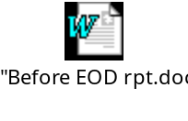

Verify Necessary Files Are At Store.

Verify Files are Updated at the Store

Purpose
When the store runs EOD, the 13 build files are moved from the I:\POS\PLUNEW directory to I:\POS. After EOD runs, the night operator should run the PrtFull report to insure all files are correctly updated. The night operator should start running this report at 1:00 AM, then hourly thereafter until all stores are updated. The Night Operator should check for correct full build creation date. This report checks for the files saved in I:\POS.

Completed by
ITS Operations

Platform and Application
DOS

Procedures
Follow the steps to Verify Files are Updated at the Store:
Step | Action
After the store runs EOD, the Night Operator should run this report to insure the correct files are at the proper location at the store. Choose:

Start → Programs → MS-DOS Prompt

A DOS window will open.
Type:
Cd \
Press enter.
Type:
CD OPS
Press enter.
Type:
Prtfull
Press enter.
 | This report will list the 13 files for all stores. Check the date created or last modified and insure it reflects the date and time of the Build Files.
 | If a file was not copied to the correct location, the Night Operator will need to POS to the store and move the necessary file(s).
Move Missing Files at Store
 | You have two choices on how to connect to the store. You can POS or ManageWise.
 | POS to Store | Or, ManageWise to store
 | Choose:  Start → Programs → MS-DOS Prompt  A DOS window will open. | To ManageWise to the store, choose;  Start → Programs → ManageWise → ManageWise Console  Or choose the ManageWise icon.
 | At the DOS prompt, type:  F:  Press enter. | On the ManageWise main menu, choose:  View → Find → Node  The Find Node screen appears.
ManageWise.gif

 | Type:  Cd \  Press enter to change directories to the root directory. | To connect to the Manger’s PC in the “Node Name” field, type:  MXX  Choose Find.  Note: The XX above represents the 2-digit store number. For example, for store #00061, type M61
ManageWise2.gif

 | Type:  Cd OPS  Press enter. | The ManageWise Console screen appears with the Store number highlighted. Double click the icon representing the store number.  Note: This is the default.
 | Type:  POSMAP XXXX  Press enter.  Note: POSMAP to the store with the missing file(s). | An error message will appear. Choose OK.
ManageWise3.gif

On the Select an Inventory Database screen, choose Cancel.
ManageWise4.gif

On the Network View screen, choose the Control Station icon. The icon is located in the top left corner of the screen.
Managewise5.gif

The Manager’s desktop screen will appear. You now have control over the Manager’s PC.

Note: Most Managers' PC's are running Windows 3.11.
 | Type:  I:  Press enter. | On the Manager’s PC, type:  F:  Press enter.
Type:
Cd \
To change directories to the root directory.
Type:
Cd POS
Press enter.
Type:
Dir
Press enter.

Note: Verify that 13 build files are NOT in the I:\POS directory.
Type:
Cd PLUNEW
Press enter.
Type:
Move *.* \POS
Press enter.

Note: This command copies the Build Store files to the store on the distribution list.
Type:
Exit
Press enter to exit DOS and return to Windows.

Note: Click on the below icon to view a sample printed copy of the PRTFull report.
After EOD rpt
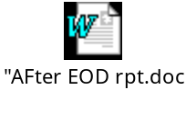

Verify Files are Updated at the Store.

Release PLU, PLU850 and ProcessPC

Purpose
After the store have successfully receive the Full Build files, the operator must release the PLU, PLU850 and ProcessPC jobs from Hold.

Platform and Application
Island Pacific

Procedures
Follow the steps to Release PLU, PLU850 and ProcessPC:
Step | Action
 | Logon the AS/400.
 | Press F12 to open a command line.
Type:
RBM
Press enter to choose the Robot command.
RBM.gif

Type:
1
Press enter to choose Job Schedule List.
Press F9 for Job Name.

The Search Options Screen opens.
Type:
1
Press enter for Job Name.
In the “Job Name” field, type:
PLU
Press enter.

The PLU job will move to the top of the list.
In the “Option” field for PLU, type:
r
Press enter.
The Job will be marked Release
In the “Job Name” field, type:
PLU
Press enter.

The PLU job will move to the top of the list.
In the “Option” field for PLU850, type:
r
Press enter.
The Job will be marked Release.
In the “Job Name” field, type:
Pro
Press enter.

The ProcessPC job will move to the top of the list.
In the “Option” field for ProcessPC, type:
r
Press enter.
The Job will be marked Release.
Press F3 to exit.

Release PLU, PLU850 and ProcessPC.

Manual Send (per Build Store)

Purpose
Sendfull and Sendpos are batch file that copy the 13 build files from the network to the store. These batch files are only used if ConnectRemote does not work. If you send the 13 files BEFORE the store runs EOD, use the Sendfull batch file. Or, if you send the 13 files AFTER the store runs EOD, use the Sendpos batch file.

Note: If store will close soon, call store and alert them they CANNOT run EOD until all Build files have been copied.

Completed by
ITS Operations

Est. Duration
1 hour, 15 minutes - 1 hour, 30 minutes per store

Platform and Application
ConnectRemote

Procedures
Follow the steps to Manual Send (Per Build Store):
Step | Action
Choose:

Start → Programs → MS-DOS Prompt

A DOS window will open.
Type:
F:
Press enter.
Type:
Cd \
Press enter.
Type:
Cd OPS
Press enter.
 | Before store runs EOD | After store runs EOD
 | If the store has NOT run EOD, you must type:  Sendfull XXXX XXXX  Press enter. | If the store has already runs EOD, you must type:  Sendpos XXXX XXXX  Press enter.
Note: The first store number represents the “Build Store” the second store number represents the “Receiving Store.”

In the below example, the Build store, 4, would be sent to store 09998 and saved at I:\POS\PLUNEW. Store 09998 would receive all 13 Build Files for the Build Store.

Sendfull 4 09998

Note: Store CANNOT run EOD during this process. Call stores and alert them.
Type:
Exit
Press enter.

Manual Send.

Alternate Manual Send

Purpose
An alternative to using the SENDFULL or SENDPOS command is to POS to the store, then copy/paste the 13 Build Files from F:\\POS\XXXX to I:\POS\PLUNEW.

Note: This method requires PC expertise. If you are unsure of the procedures, consult with the ITS Operations Team Lead.

Platform and Application
POS and Windows Explorer

Procedures
Follow the steps to Alternate Manual Send:
Step | Action
Choose:

Start → Programs → MS-DOS Prompt

A DOS window will open.
At the DOS prompt, type:
F:
Press enter.
Type:
Cd \
Press enter to change directories to the root directory.
Type:
Cd OPS
Press enter.

Type:
POSMAP XXXX
Press enter.

Note: POSMAP to the store with the missing file(s).
Open Windows Explorer by choosing:

Start → Programs → Windows Explorer
Move to the following directory in Windows Explorer:

F:\\POS\XXXX

Note: Delete the PLU.RPT file if it exists in the above directory.
 | Choose the 13 Build Files by holding down the shift key and clicking on the 13 Build Files. After all the files have been chosen, release the shift key.
Choose:
File → Copy
Move to the following directory in Windows Explorer:

I:\POS\PLUNEW
Choose:
File → Paste

Note: This will copy the 13 Build Files from F:\\POS\XXXX to I:\POS\PLUNEW.

Alternate Manual Send.

Overview

Est. Duration per Section
Section | Title | Menu/Option or Command | Est. Duration
 | Hold PLU and ProcessPC Jobs | RBM | N/A
 | Disable ConnectRemote |  | N/A
 | Input & Release MD/PC Entries |  | N/A
 | Process Pending MD/PC Entries | 9/3 | 30 min -12 hrs
 | Print Pending MD/PC Entries | 9/2 | 5-30 min
 | Format MD/PC Entries for PLU | 27/13 | 30 min – 12 hrs
 | Verify Prices | Wrksplf  IP207b
 | Run JFF 850 | 661/36 | 30 min – 12 hrs
 | Clear Library JFFPLUS | 216/11 | 30 min
 | Information to ITS |  | N/A
 | Create PLU by Item Range, as needed | 27/14 | 1 hr, 30 min
 | Define Job Schedules, as needed | 10/7 | N/A
 | Manually Run Job from Job List | 10/8 | 15 min
 | Start Job Schedule | 10/9 | N/A
 | Run JFF 850 | 661/36 | 30 min – 7 hrs, 30 min (depending on number of build stores)
 | Display, Rename & Create Library JFFPLUS | Display - Wrklib JFFPLUS  Rename - Wrkobj JFFPLUS #7  Create – Crtlib JFFPLUS | Display – 5 min  Rename – 2 min  Create – 1 min
 | FTP Files to Network (per Build Store) |  | 30 min
 | Run FullBld to Create 13 Build Files (per Build Store) and Review |  | 1 hr – 4 hrs per store
 | Send Build to Lab for testing
 | ConnectRemote Send (per store) |  | 1 hr, 15 min – 1 hr 30 min per Build Store
 | Verify Necessary Files are at Store |  | N/A
 | Verify Files are Updated at Store |  | N/A
 | Manual Send (per Build Store) |  | 1 hr, 15 min – 1 hr, 30 min per store
 |  | Total Est. Time | 24 hrs

Overview.

Time Comparison

Purpose
Many factors are involved in the time it takes to complete a build:
- PC used
- Broadcast messages
- Size of ALT and PLU file
- Any programs running
- Available space on C:\ drive

Time Comparison
PC Used | Store Number | PLU Size | ALT Size | Start Time | Finish Time | Total Time
D | 86 | 38 | 16 | 1:15 | 2:30 | 1 hr, 15 min
D | 3 | 75 | 31 | 1:45 | 5:15 | 3 hr, 30 min
D | 11 | 75 | 15 | 4:40 | 8:00 | 3 hr, 30 min
D | 13 | 75 | 31 | 5:15 | 8:45 | 3 hr, 30 min
D | 71 | 74 | 31 | 8:45 | 12:15 | 3 hr, 30 min
D | 81 | 75 | 31 | 10:05 | 1:30 | 3 hr, 25 min
D | 87 | 37 | 15 | 12:15 | 1:15 | 1 hr
G | 9 | 75 | 31 | 3:30 | 7:35 | 4 hr, 5 min
G | 50 | 74 | 31 | 7:35 | 11:25 | 3 hr, 50 min
G | 88 | 37 | 15 | 11:25 | 12:35 | 1 hr, 10 min
G | 4 | 75 | 31 | 11:30 | 3:20 | 3 hr, 50 min
G | 83 | 37 | 15 | 12:35 | 1:50 | 1 hr, 15 min
J | 11 | 75 | 31 | 3:40 | 5:20 | 1 hr, 40 min
J | 29 | 75 | 31 | 5:20 | 6:55 | 1 hr, 35 min
J | 43 | 75 | 31 | 6:55 | 9:30 | 2 hr, 25 min
J | 73 | 74 | 31 | 9:30 | 12:10 | 2 hr, 40 min
J | 69 | 37 | 15 | 12:10 | 1:55 | 1 hr, 45 min

Time Comparison.

Checklist
Click the below icon to view the Full Build Checklist.
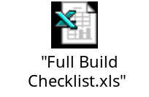

Checklist

Full Build Flowchart
Click on the below icon to view the Full Build Flowchart.

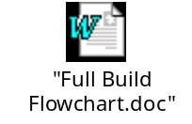

Full Build Flowchart.

Full Build.

